SwipeLab
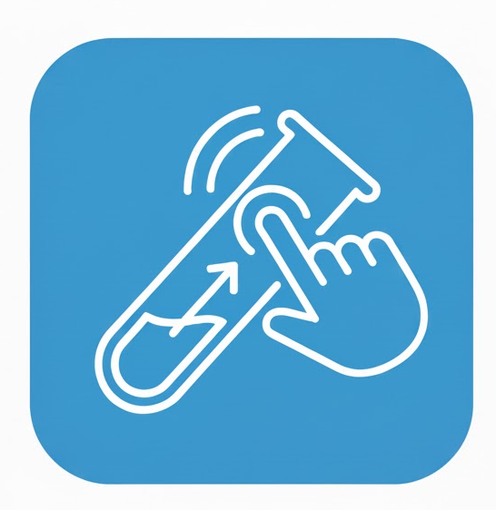

Application Design Document

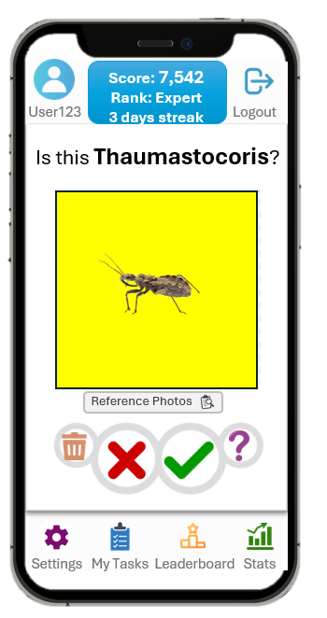
Technical Advisor Chen Kaesar
Academic Advisor Robert Moskovich
Team Members
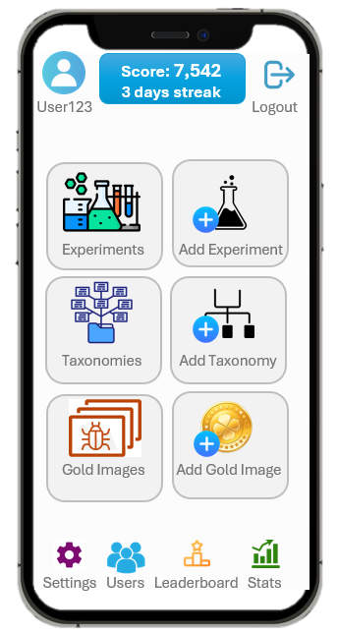
- Sagi Evroni
- Eden Bar
- Ofri Hanochi
- Avihoo Amos

SwipeLab 1
1. Use Cases 3
2. System Architecture 10
2.1 Overview 10
2.2 Subsystems and Components 10
2.3 Interfaces and Communication 11
2.4 Technology Stack 11
3. Data Model 12
3.1 Description of Data Objects 12
3.2 Data Objects Relationships 14
3.3 Databases 14
4. Behavioral Analysis 15
4.1 Sequence Diagrams 16
4.2 Events 16
4.3 States 16
5. Object-Oriented Analysis 17
5.1 Class Diagrams 17
5.2 Class Description 17
5.3 Packages 22
5.4 Unit Testing 23
6. User Interface Draft 23
7. Testing 24
8. Appendices 24

1. Use Cases
UC-1: Register New Account
- Primary Actor: Volunteer (Guest User)
- Description: A new user creates an account to access the SwipeLab platform.
- Trigger: The user launches the app and taps "Sign Up" or "Create Account."
- Preconditions:
  - The app is installed.
  - The device has an active internet connection.
- Postconditions:
  - A new user record is created in the database.
  - The user is logged in or prompted to verify their email.
- Main Success Scenario:
  - The user navigates to the registration screen.
  - The user enters a Username (3-20 characters).
  - The user enters a valid Email Address.
  - The user creates a Password (min 8 characters).
  - The user enters a Display Name.
  - The user submits the form.
  - The system validates the input and creates the account.
  - The system confirms successful registration.
UC-2: Authenticate and Onboard
- Primary Actor: Volunteer (End User)
- Description: The user securely logs into the application and is shown a brief introduction to the project's purpose.
- Trigger: The user opens the application for the first time or after being logged out.
- Preconditions:
  - The app is installed on the user's mobile device.
  - The device has an active internet connection.
- Postconditions:
  - The user is authenticated, and a secure session is created.
  - The user's profile (for tracking points and credibility) is created or retrieved.
- Main Success Scenario:
  - The user opens the app and is presented with the "Login / Onboarding" screen.
  - The screen provides a short intro explaining the project's purpose and privacy.
  - The user taps the "Google Sign-In" button.
  - The system uses OAuth2 to securely authenticate the user with their Google account.
  - The backend verifies the user's token and links them to their SwipeLab profile.
  - The system proceeds to the main "Classification Screen" (UC-2).

UC-3: Select and Play Task
- Primary Actor: Volunteer (End User)
- Description: The user browses their assigned tasks, views details for a specific task, and begins the classification session.
- Trigger: The user navigates to the "My Tasks" dashboard.
- Preconditions:
  - The user is logged in.
  - At least one task is assigned to the user (or available publicly).
- Postconditions:
  - The user enters the classification mode (Swipe Screen) for the selected task.
- Main Success Scenario:
  - The user views the "My Tasks" page.
  - The system displays a paginated list of available tasks.
  - The user selects a specific task from the list.
  - The system retrieves and displays the task details (e.g., description, progress).
  - The user taps the "Play" or "Start" button.
  - The system initializes a classification session for that task ID.

UC-4: Classify Image Stream
- Primary Actor: Volunteer (End User)
- Description: The user classifies a stream of images using simple swipe gestures to earn points and contribute data to the research project.
- Trigger: The user is logged in and is on the "Classification Screen".
- Preconditions:
  - The user is authenticated (UC-1).
- Postconditions:
  - The user's classifications are stored in the backend database.
  - The user's points and reliability score are updated.
- Main Success Scenario:
  - The system retrieves and displays an image from the STARdbi dataset API.
  - The user analyzes the image and swipes (or taps) "Yes," "No," or "I Don't Know" or “Trash”.
  - The system provides immediate visual feedback for the action.
  - The system securely records the user's label and associated metadata (e.g., response time).
  - The system updates the user's points and progress bar.
  - The system serves the next image in the batch.
- Alternative Flows:
  - 2a. System serves a "Trap Image":
    - The system retrieves and displays a "gold-standard" image with a known label.
    - The user provides a classification.
    - The system compares the user's answer to the known label and updates the user's hidden "credibility score".

UC-5: View Personal Progress and Leaderboard
- Primary Actor: Volunteer (End User)
- Description: The user accesses their personal statistics and the community leaderboard to track their progress and ranking, which directly supports the project goal of increasing user engagement.
- Trigger: The user taps on the "Progress" or "Leaderboard" tab/button in the app.
- Preconditions:
  - The user is logged in (UC-1).
- Postconditions:
  - None (this is a view-only action).
- Main Success Scenario (Personal Stats):
  - User navigates to the "Progress / Points Screen".
  - The system retrieves and displays the user’s personal statistics, including:
    - Total points earned.
    - Badges unlocked.
    - Credibility score/level.
    - Total classifications.
    - Accuracy vs. expert consensus.
    - Time spent and streak days.
- Main Success Scenario (Leaderboard):
  - User navigates to the "Leaderboard" screen.
  - The system retrieves and displays a list of top contributors, such as the "LabSwiper of the Week / Month" .
UC-6: View and Track Challenges
- Primary Actor: Volunteer (End User)
- Description: The user views available gamification challenges (e.g., Daily, Weekly, Streak) to understand their current objectives and progress.
- Trigger: The user taps on the "Challenges" tab.
- Preconditions:
  - The user is logged in.
- Postconditions:
  - User is aware of active goals.
- Main Success Scenario:
  - The system fetches the list of challenges (Daily, Weekly, Streak, Milestone).
  - The system calculates and displays the progress percentage for each challenge (e.g., "10/20 images classified").
  - The system visually distinguishes between "In Progress" and "Completed" challenges.
  - The user taps a challenge to view the specific reward (e.g., "Silver Badge").

UC-7: Add a New Classification Task
Primary Actor: Research Scientist (Administrator)
Description: The researcher creates a new classification task for a specific bug or organism type by uploading reference pictures and defining the classification question to guide mobile app users.
Trigger: The researcher navigates to the Research Dashboard and clicks "Create New Classification Task."
Preconditions:
- The researcher has administrator-level credentials.
- The researcher has prepared reference images showing the target organism.
- At least one dataset exists or is being uploaded concurrently.
Postconditions:
- A new classification task is created with reference pictures.
- The task is associated with a dataset and available to mobile users.
- Users can view reference pictures when classifying this task.
Main Success Scenario:
- The researcher logs into the research dashboard.
- The researcher clicks "Create New Classification Task."
- The system displays the task creation form.
- The researcher enters task details:
  - Task name (e.g., "Asian Giant Hornet Identification")
  - Classification question (e.g., "Is this an Asian Giant Hornet?")
  - Brief description of identifying features
- The researcher uploads 3-10 reference pictures showing clear examples of the target organism.
- For each reference picture, the researcher adds captions explaining key features.
- The researcher optionally uploads negative examples (similar-looking species for comparison).
- The researcher configures quality parameters (minimum classifications per image, consensus threshold).
- The researcher reviews the configuration and clicks "Create Task."
- The system validates the task configuration and stores the reference images.
- The researcher associates the task with an existing dataset.
- The system activates the task and makes it available to mobile app users.
- When users first encounter this task, they see a tutorial displaying the reference pictures.
Alternative Flows:
- 5a. No reference images uploaded: System warns but allows task creation if researcher confirms.
- 10a. Validation fails (missing required information): System highlights issues and prevents creation until resolved.
- 11a. No suitable dataset exists: System prompts researcher to upload dataset first.
- 13a. User skips tutorial: Reference pictures remain accessible via info button during classification.

UC-8: Define Trap Pictures for User Reliability Grading
Primary Actor: Research Scientist (Administrator)
Description: The researcher defines "trap pictures" (also known as gold standard or quality control images) with known correct classifications. These images are inserted into user classification queues to measure accuracy and calculate user reliability scores.
Trigger: The researcher navigates to the SwipeLab "Research Dashboard" and selects an existing classification task to add quality control images.
Preconditions:
- The researcher has administrator-level credentials.
- A classification task has been created.
- The researcher has expert-verified correct labels for selected images.
- At least 10 images are available in the dataset to serve as trap pictures.
Postconditions:
- Trap pictures are designated in the system with their correct classifications.
- The system begins inserting trap pictures into user classification queues at the specified frequency.
- User reliability scores can be calculated based on accuracy on trap pictures.
- The researcher can monitor user performance against trap pictures in real-time.
Main Success Scenario:
- The researcher logs into the research dashboard.
- The researcher navigates to the classification task detail page.
- The researcher clicks on the "Quality Control" or "Trap Pictures" tab.
- The system displays all images in the dataset with their current classification status.
- The researcher selects images to designate as trap pictures (recommended: 5-15% of total dataset).
- For each selected trap picture, the researcher provides the correct classification (e.g., "Yes" - this is a bee, "No" - this is not a bee)
- The researcher configures trap picture parameters:
  - Insertion frequency (e.g., 1 trap picture every 10-15 regular images)
  - Whether to provide immediate feedback to users after trap picture classification
  - Reliability score impact weight (how much each correct/incorrect answer affects user score)
  - Minimum number of trap pictures a user must encounter before reliability score is calculated
- The researcher reviews the trap picture configuration and distribution settings.
- The researcher clicks "Activate Trap Pictures."
- The system validates that trap pictures represent diverse difficulty levels and image types.
- The system saves the trap picture configuration and begins inserting them into active user queues.
- The system displays a confirmation message: "Trap pictures activated. User reliability tracking is now enabled."
- The researcher can view real-time reliability statistics on the dashboard.

UC-9: Manage Recipient Groups
- Primary Actor: Researcher (Administrator)
- Description: The admin creates a defined list of users (Recipient Group) that can be targeted for specific classification tasks (e.g., "Expert Annotators", "Biology Students").
- Trigger: The researcher navigates to the "Recipient Groups" management section.
- Preconditions:
  - The researcher has administrator privileges.
- Postconditions:
  - A new recipient group is saved in the database.
  - The group becomes available for assignment in the Task Editor.
- Main Success Scenario:
  - The researcher selects "Create Recipient Group."
  - The researcher enters a group name.
  - The researcher selects or inputs a list of user identifiers (usernames or emails) to include in the group.
  - The researcher saves the group.
  - The system validates the users exist and stores the group.
UC-10: Edit Classification Task
- Primary Actor: Researcher (Administrator)
- Description: The researcher updates the configuration of an existing task, including modifying its description, target species, or assigned user groups.
- Trigger: The researcher selects an existing task and clicks "Edit."
- Preconditions:
  - The task exists.
  - The researcher has administrator privileges.
- Postconditions:
  - The task configuration is updated in the database.
- Main Success Scenario:
  - The system loads the current task data.
  - The researcher updates the Task Name or Description.
  - The researcher adds or removes Target Species configurations.
  - The researcher modifies the Experiments linked to the task.
  - The researcher updates the Recipient Groups to change who receives the task.
  - The researcher saves the changes.
  - The system updates the task and applies the new rules immediately.

UC-11: Analyze and Export Data
- Primary Actor: Researcher (Administrator)
- Description: The researcher logs into the web dashboard to monitor the quality of the incoming labels and export a cleaned dataset for use in model training.
- Trigger: The researcher navigates to the SwipeLab "Research Dashboard" and logs in.
- Preconditions:
  - The researcher has administrator-level credentials.
  - Volunteers have submitted a sufficient number of classifications.
- Postconditions:
  - The researcher receives a downloadable file (e.g., CSV, JSON) containing high-quality labeled data.
- Main Success Scenario:
  - The researcher logs into the research dashboard.
  - The system displays an overview of statistics, user stats, and consensus levels.
  - The researcher navigates to the "Export Data" section.
  - The researcher applies filters, such as a minimum "user reliability score," to exclude low-quality data.
  - The researcher clicks "Generate Export."
  - The system queries the database, filters the labels, and generates a file in the selected format.
  - The researcher downloads the file.

2. System Architecture

2.1 Overview
The SwipeLab system follows a classic Client-Server Architecture, designed to support mobile-first data collection while maintaining centralized data management and analysis. The system is composed of three primary subsystems: the Mobile Application (Frontend), the Backend API Server, and the Database. Additionally, the system integrates with the external STARdbi infrastructure to retrieve raw insect imagery.
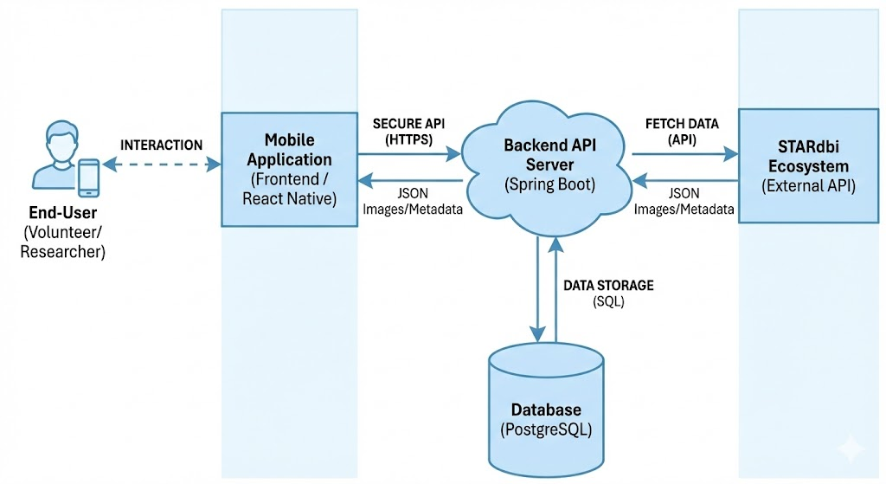

2.2 Subsystems and Components
2.2.1 Mobile Application (Frontend)
The frontend is a cross-platform mobile application built using React Native (Expo), ensuring compatibility with both iOS and Android devices. It serves as the primary interface for volunteers ("Citizen Scientists") and includes the Research Dashboard for administrators.
- Responsibilities:
  - User Interface: Renders the "Tinder-style" swipe interface for image classification.
  - Gamification Engine: Displays points, badges, and leaderboards to motivate users.
  - Local Persistence: Caches images and classification queues to support offline functionality.
  - Admin Dashboard: Provides researchers with screens to manage tasks, upload gold images, and view analytics (implemented via shared React Native screens).
2.2.2 Backend API Server
The backend is a monolithic application built with Java Spring Boot, structured into a layered architecture (Controller, Service, Repository). It acts as the central orchestrator for the system.
- Responsibilities:
  - API Gateway: Exposes secure RESTful endpoints for the mobile client.
  - Authentication & Security: Manages user identity using OAuth2 (Google) and JWT for session management.
  - Business Logic: Executes core algorithms for consensus calculation (aggregating user votes), credibility scoring (weighting users based on accuracy), and fraud detection.
  - Integration: Fetches raw data from the external STARdbi API and serves it to users.
2.2.3 Data Storage (Database)
The system uses PostgreSQL as its primary relational database management system (RDBMS).
- Responsibilities:
  - Persists structural data including Users, Tasks, Images, Classifications, and Gamification Stats (Badges, Points).
  - Ensures data integrity and transactional consistency for classification submissions.
2.2.4 External Systems (STARdbi)
The system relies on the STARdbi Ecosystem as the authoritative source of raw data.
- Interaction: SwipeLab pulls batches of insect trap scans and metadata from the STARdbi Dataset API.
- Data Flow: Unlabeled images flow from STARdbi to SwipeLab; Aggregated, labeled datasets are exported from SwipeLab back to researchers.

2.3 Interfaces and Communication
- Client-Server Communication: The Mobile App communicates with the Backend Server via HTTPS using RESTful API standards. All data is exchanged in JSON format.
- Authentication: Communication is secured using JWT (JSON Web Tokens) included in the HTTP Authorization header.
- External API: The Backend Server communicates with the STARdbi API via HTTP requests to fetch image URLs and metadata.

2.4 Technology Stack
- Frontend Framework: React Native (Expo), TypeScript.
- Backend Framework: Java Spring Boot.
- Database: PostgreSQL.
- Security: Spring Security, OAuth2, JWT.
- Cloud/Infrastructure: AWS S3 (or similar) for image storage integration.
- Figure 2.1: SwipeLab system architecture, detailing the secure communication between the Mobile Application and Backend API Server, as well as the backend's integration with the database and the external STARdbi ecosystem.

3. Data Model

3.1 Description of Data Objects
The SwipeLab data model consists of the following core entities that represent the system's state and business logic.

1. User
Represents a registered user (Volunteer or Researcher) in the system.
- Key Attributes:
  - username (Primary Key): Unique identifier.
  - email: User's contact email.
  - role (UserRole): Determines permissions (e.g., USER, ADMIN).
  - credibilityScore (Double): A calculated score (0.0 - 100.0) reflecting the user's reliability based on gold standard images.
  - points (Long): Gamification currency earned by classifying.
  - currentStreak (Integer): Consecutive days of activity.
  - authProvider (AuthProvider): Indicates if the user logged in via Local auth or OAuth (Google).
2. Task
Represents a specific classification assignment created by a researcher.
- Key Attributes:
  - title & description: Metadata describing the scientific goal.
  - status (TaskStatus): Lifecycle state (DRAFT, ACTIVE, PAUSED, ARCHIVED).
  - minClassificationsPerImage: The number of votes needed per image to consider it "done".
  - consensusThreshold: The percentage of agreement required (e.g., 80%).
3. Image
Represents a single visual data point to be classified.
- Key Attributes:
  - imageUrl: URL pointing to the image storage (e.g., S3).
  - isGoldStandard (Boolean): Flags if this is a "trap" image with a known answer for quality control.
  - priority: Determines the order in which images are served to users.
4. Classification
Represents a single vote cast by a user on an image.
- Key Attributes:
  - timestamp: When the swipe occurred.
  - Associations: Links a specific User to a specific Image with a chosen Label.
5. Label
Represents a taxonomic category or answer option (e.g., "Wasp", "Not Wasp").
- Key Attributes:
  - name: The scientific or display name.
  - description: Additional context for the user.
6. RecipientGroup
Represents a defined cohort of users (e.g., "Biology Class A") that can be assigned private tasks.
- Key Attributes:
  - name: Unique name for the group.
  - users: A set of users belonging to this group.
7. Badge
Represents a gamification achievement.
- Key Attributes:
  - name: The display title of the achievement.
  - criteriaJson: A JSON structure defining the rules to unlock this badge.
  - iconUrl: Visual asset for the UI.

3.2 Data Objects Relationships
The entities are related as follows:
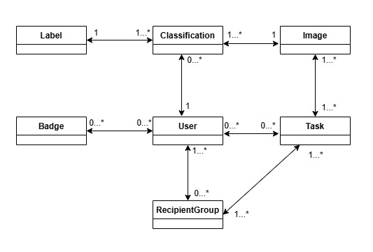

3.3 Databases
The system uses PostgreSQL as its Relational Database Management System (RDBMS).
- Justification: PostgreSQL was chosen for its robustness, strong support for complex queries (needed for consensus algorithms and analytics), and reliability in handling relational data structures.
- Schema Generation: The database schema is managed via Flyway migrations (as seen in src/main/resources/db/migration), ensuring version control and consistency across development and production environments.
Table Descriptions
The database consists of the following primary tables:
- users Stores all registered user accounts, including authentication credentials (password hash or OAuth IDs), profile details, and gamification statistics (points, credibility score, streaks).
- tasks Contains the definitions of classification assignments, including title, description, configuration parameters (consensus thresholds), and lifecycle status (DRAFT, ACTIVE, etc.).
- images Stores references to the insect images. It includes the image URL, priority level, and flags indicating if it is a "Gold Standard" (trap) image for quality control.
- classifications Records the individual votes cast by users. Each row links a user, an image, and a chosen label, acting as the central transactional record of the system.
- labels Defines the taxonomic categories (e.g., specific insect species or families) that users can select as answers.
- badges Contains the definitions of available gamification achievements, including their display names, icons, and the JSON logic required to unlock them.
- recipient_groups Stores named cohorts of users (e.g., "Biology Students 2024") created by administrators for targeted task distribution.

Join Tables
The following tables handle many-to-many relationships:
- user_badges: Maps users to the badges they have earned.
- recipient_group_users: Maps individual users to specific recipient groups.
- task_target_species: Links tasks to the specific labels (species) relevant for that assignment.
- task_recipient_groups: Links tasks to the recipient groups that are authorized to perform them.
Data Transactions
The SwipeLab system utilizes ACID-compliant transactions (Atomic, Consistent, Isolated, Durable) managed by the Spring Framework’s declarative transaction management (@Transactional). This ensures that complex business operations involving multiple database tables either complete fully or roll back entirely, preventing data corruption.
The system defines the following critical transactional boundaries:
1. Classification Submission (Critical)
When a user swipes on an image, the system performs multiple updates that must occur atomically:
- Record Classification: A new row is inserted into the classifications table.
- Update User Stats: The user's total_classifications count is incremented.
- Award Points: The user's points balance is updated in the users table.
- Update Streak: If applicable, the user's current_streak and last_streak_update fields are modified.
- Check Consensus: If the image reaches the consensus threshold, its status is updated.
Constraint: If any step fails (e.g., database connection loss during point calculation), the entire transaction is rolled back. The user’s swipe is not recorded, and no partial points are awarded, ensuring the gamification state remains consistent with the scientific data.
2. User Registration
The onboarding process involves initializing several data entities simultaneously:
- Create User: A new record is saved in the users table.
- Initialize Profile: Default settings and an initial "neutral" credibility score are assigned.
- Token Generation: For local auth, verification tokens are generated and stored.
3. Task Management (Admin)
When a researcher creates or modifies a task:
- Save Task: The Task entity is persisted.
- Link Images: Associations between the task and potentially thousands of Image records are established.
- Update Metadata: Target species (Labels) and recipient groups are linked.
Constraint: This prevents "orphan" tasks that exist without their required configuration or images.

4. Behavioral Analysis

4.1 Sequence Diagrams
TODO !

4.2 Events
TODO !

4.3 States
TODO !

5. Object-Oriented Analysis

5.1 Class Diagrams
TODO !

5.2 Class Description
1. Class: Task
Type: Entity (Domain Model)
Description: Represents a classification assignment created by a researcher. It contains the configuration for the scientific experiment and manages its own lifecycle state (Draft, Active, Paused, Archived).
- Main Fields:
  - status (TaskStatus): The current state of the task (e.g., DRAFT, ACTIVE).
  - minClassificationsPerImage (Integer): The number of independent user votes required before an image is considered "finished".
  - consensusThreshold (Double): The percentage of agreement required to validate a label (default 80.0).
  - targetSpecies (List<Label>): The specific insects or objects users are asked to identify.
- Invariants:
  - minClassificationsPerImage must be greater than 0.
  - consensusThreshold must be between 0.0 and 100.0.
- Method: activate()
  - Pre-condition: status is either DRAFT or PAUSED.
  - Post-condition: status is updated to ACTIVE.
- Method: archive()
  - Pre-condition: status is either ACTIVE or PAUSED.
  - Post-condition: status is updated to ARCHIVED.
2. Class: User
Type: Entity (Domain Model)
Description: Represents a registered volunteer or researcher. It stores personal details, authentication credentials, and gamification progress (scores, streaks).
- Main Fields:
  - username (String): Unique identifier for the user.
  - credibilityScore (Double): A calculated value representing the reliability of the user's classifications.
  - points (Long): Accumulated gamification currency earned by completing tasks.
  - currentStreak (Integer): The number of consecutive days the user has been active.
- Invariants:
  - email must be unique across the system.
  - points cannot be negative.
3. Class: ClassificationService
Type: Service (Business Logic)
Description: Orchestrates the core "swiping" workflow. It handles the submission of user votes, triggers fraud detection, calculates points, and updates streaks.
- Main Dependencies: ClassificationRepository, PointsService, StreakService, FraudDetectionService.
- Method: submitClassification(String username, ClassificationRequest request)
  - Pre-conditions:
    - username corresponds to a valid, existing User.
    - request.imageId corresponds to a valid Image.
    - request.labelId corresponds to a valid Label.
    - The user has not already classified this specific image.
  - Post-conditions:
    - A new Classification record is saved to the database.
    - If the image was a "Gold Standard" image, the user's accuracy is evaluated.
    - The user's totalClassifications count is incremented.
    - The user's points are increased (base points + potential bonus).
    - The user's daily streak is updated/extended.
4. Class: AuthenticationService
Type: Service (Business Logic)
Description: Manages the user registration and login processes, including security checks and token generation.
- Main Dependencies: UserRepository, JwtService, AuthenticationManager.
- Method: register(RegisterRequest request)
  - Pre-conditions:
    - request.email does not already exist in the database.
    - request.username does not already exist in the database.
  - Post-conditions:
    - A new User is created with role = USER and provider = LOCAL.
    - A JWT access token and refresh token are generated and returned.
- Method: verifyEmail(String token)
  - Pre-conditions:
    - The token is valid and matches a user's emailVerificationToken.
    - The token has not expired.
  - Post-conditions:
    - The user's emailVerified status is set to true.
    - The verification token is cleared from the user record.
5. Class: AnalyticsService
Type: Service (Business Logic)
Description: Responsible for aggregating raw classification data into actionable insights for researchers. It calculates consensus levels, tracks task progress, and evaluates user accuracy against Gold Standard images.
- Main Dependencies: TaskRepository, ClassificationRepository, UserRepository.
- Method: getTaskAnalytics(Long taskId)
  - Description: Aggregates all classifications for a task to calculate the overall consensus percentage, completion rate, and label distribution.
  - Post-condition: Returns a TaskAnalyticsResponse containing counts of "Low Consensus" (< 60%) vs "High Consensus" (> 80%) images.
- Method: getUserPerformanceMetrics(Long taskId)
  - Description: Generates a performance report for all users who contributed to a specific task.
  - Logic: Sorts users based on their goldAccuracy (percentage of correct calls on trap images).
6. Class: PointsService
Type: Service (Gamification)
Description: Manages the economic logic of the gamification system. It calculates point rewards based on user behavior and applies multipliers for consistent activity (streaks).
- Method: calculateAndAddPoints(User user, int basePoints)
  - Logic: Applies a multiplier to basePoints based on the user's currentStreak:
    - Streak ≥ 30 days: 1.5x multiplier.
    - Streak ≥ 14 days: 1.25x multiplier.
    - Streak ≥ 7 days: 1.1x multiplier.
  - Post-condition: The user's total points balance is updated in the database.
7. Class: Badge
Type: Entity (Gamification)
Description: Represents a specific achievement or milestone that users can unlock (e.g., "Bee Expert", "Early Bird").
- Main Fields:
  - name (String): Unique identifier for the badge.
  - criteriaJson (String): A JSON structure defining the rules required to unlock the badge (allows for flexible, dynamic criteria without changing the schema).
  - iconUrl (String): Visual asset for the UI.
8. Class: Image
Type: Entity (Domain Model)
Description: Represents the core unit of work in the system—a single photo requiring classification. It can be a standard sample or a "Gold Standard" image used for quality control.
- Main Fields:
  - imageUrl (String): Location of the file storage.
  - isGoldStandard (Boolean): Flag indicating if this is a "trap" image with a known answer.
  - correctLabel (Label): The ground-truth answer (Required if isGoldStandard is true).
  - priority (Integer): Determines the likelihood of this image being served to users earlier than others.
9. Class: ImageService
Type: Service (Business Logic)
Description: Manages the lifecycle of images, including ingestion (upload) and distribution (batching) to users.
- Method: uploadImage(ImageUploadRequest request)
  - Pre-condition: If isGoldStandard is true, a correctLabelId must be provided.
  - Post-condition: Returns the created ImageResponse.
- Method: getImageBatch(Long taskId, String username)
  - Logic: Retrieves images for the task, filters out any images the specific username has already classified, shuffles the remaining set, and returns a limited batch (e.g., 20 images).
  - Invariant: A user should never receive an image they have already seen (unless explicitly reviewing).
10. Class: AdminDashboardService
Type: Service (Business Logic)
Description: The primary service for Researcher/Admin operations. It allows the management of tasks, lifecycles, and user groups.
- Method: createTask(CreateTaskRequest request)
  - Post-condition: A new task is persisted with status ACTIVE and is immediately available for distribution.
- Method: createRecipientGroup(CreateRecipientGroupRequest request)
  - Purpose: creates a named cohort of users (e.g., "Biology Students 2024") that can be assigned specific private tasks.
  - Invariant: Group name must be unique.

5.3 Packages
5.3.1 Backend Packages
The SwipeLab backend system is organized into a modular package hierarchy rooted at com.swipelab. This structure separates concerns into distinct layers: configuration, presentation (API), business logic, data access, and domain modeling.

Root Package: com.swipelab
Contains the main application entry point (SwipeLabApplication.java).
1. Presentation Layer (.controller)
Handles incoming HTTP requests and defines the REST API endpoints.
- com.swipelab.controller: Contains all REST controllers (e.g., AuthController, TaskController, ClassificationController).

2. Business Logic Layer (.service)
Contains the core business rules and transaction management. This layer is further divided into functional modules:
- com.swipelab.service: General services (e.g., TaskService, ImageService).
  - .analytics: Logic for data export, statistics generation, and performance metrics.
  - .auth: Authentication logic, including Email verification and OAuth2 processing.
  - .classification: Core logic for handling user swipes, fraud detection, and consensus calculation.
  - .gamification: Logic for the reward system, including badges, leaderboards, points, and streaks.
  - .integration: Services responsible for communicating with external systems (e.g., the STARdbi API).
  - .user: Management of user profiles, credibility scores, and dashboard data.
3. Data Access Layer (.repository)
Interfaces for database interaction using Spring Data JPA.
- com.swipelab.repository: Repository interfaces (e.g., UserRepository, TaskRepository, ClassificationRepository) that handle CRUD operations and custom queries.
4. Domain Model (.model)
Defines the data structure of the application.
- com.swipelab.model
  - .entity: JPA Entities representing database tables (e.g., User, Task, Image, Badge).
  - .enums: Enumerations for state management (e.g., UserRole, TaskStatus, AuthProvider).
5. Data Transfer (.dto)
Objects used to transfer data between the client and server, decoupling the API from the internal database model.
- com.swipelab.dto
  - .request: input payloads (e.g., RegisterRequest, ClassificationRequest).
  - .response: output payloads (e.g., TaskResponse, UserProfileResponse).
    - .dashboard: Specialized responses for the user and admin dashboard views.
6. Infrastructure & Support
- com.swipelab.config: Configuration classes for Spring Security, JWT, OAuth2, and Async execution.
- com.swipelab.security: Security components including JWT providers, filters, and UserDetails services.
- com.swipelab.exception: Global exception handling and custom application exceptions (e.g., ResourceNotFoundException).
- com.swipelab.mapper: Utilities for transforming Entities into DTOs and vice-versa.
- com.swipelab.util: Helper classes for mathematical calculations (Consensus, Credibility) and Date/Time handling.

5.4 Unit Testing
TODO !

6. User Interface Draft
6.1 User’s Interface (Player Mode)
Those screens are intended for a regular users such as volunteers, researchers and anyone who is assigned to a labeling task.
6.1.1 User Login
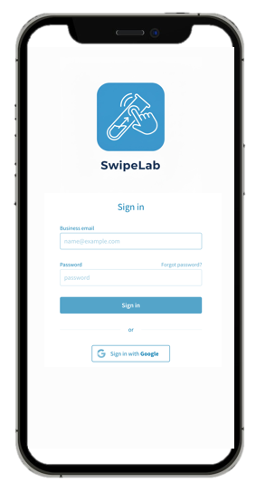
Login via email & password
Login via Google account
Logout Button
6.1.2 Main User’s Page
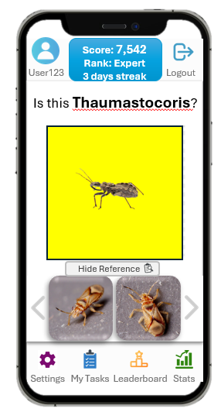
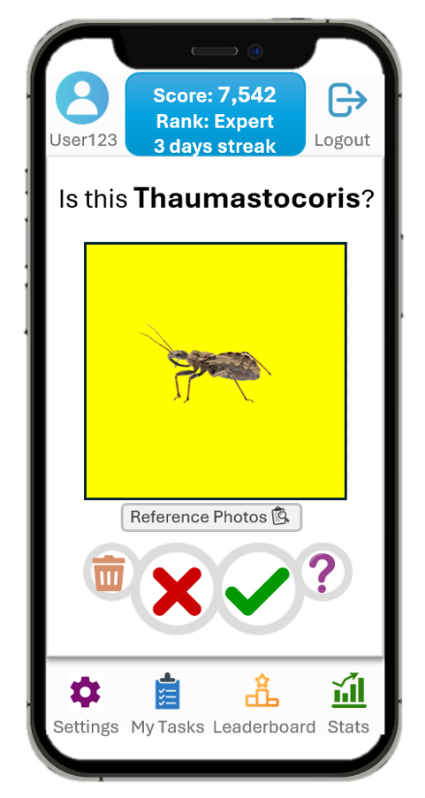
User Info Button

Challenges Button
Swipe Area

Reference Images Button

YES/NO/DON’T KNOW/TRASH
Toolbar Component
6.1.3 User’s Task Page
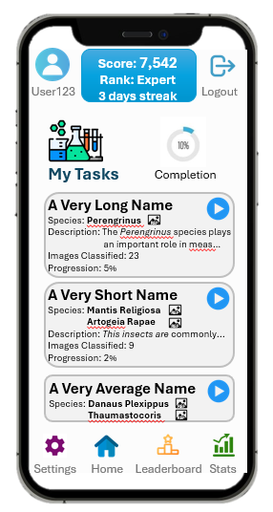
6.1.4 Leaderboard Page
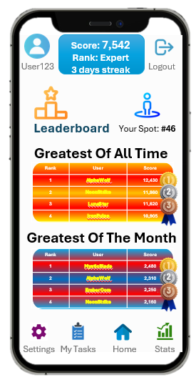

6.1.5 Stats Page (User’s Progression)
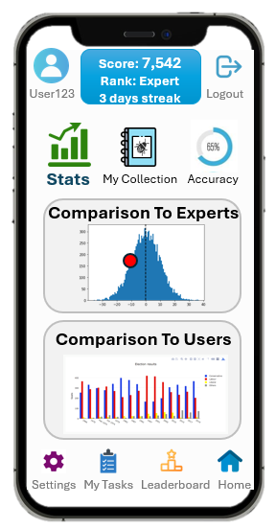
6.1.6 Challenges Page
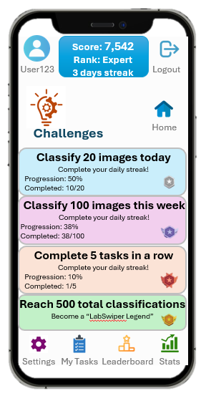

6.1.7 User’s Info Page
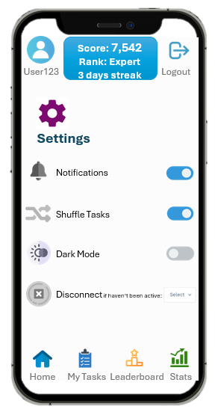
6.1.8 Settings Page

6.2 Admin’s Interface (Manager Mode)
Those screens are intended for a researcher who wants to create and manage tasks, manage users and analyze the labeling data by the SwipeLab app.
6.2.1 Manger’s Dashboard (Main Page)
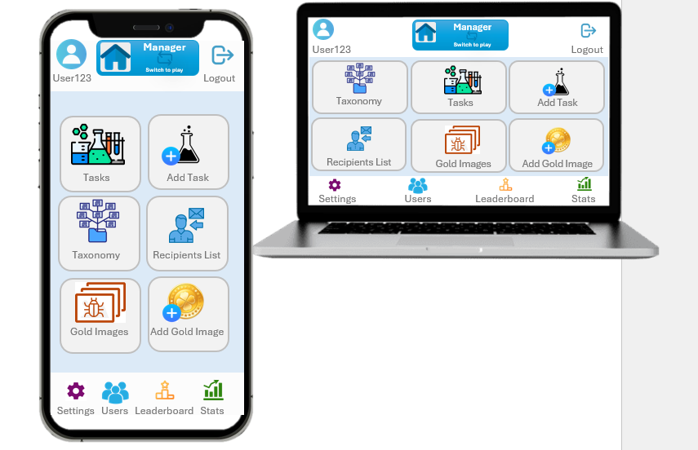
6.2.2 Tasks Management Page
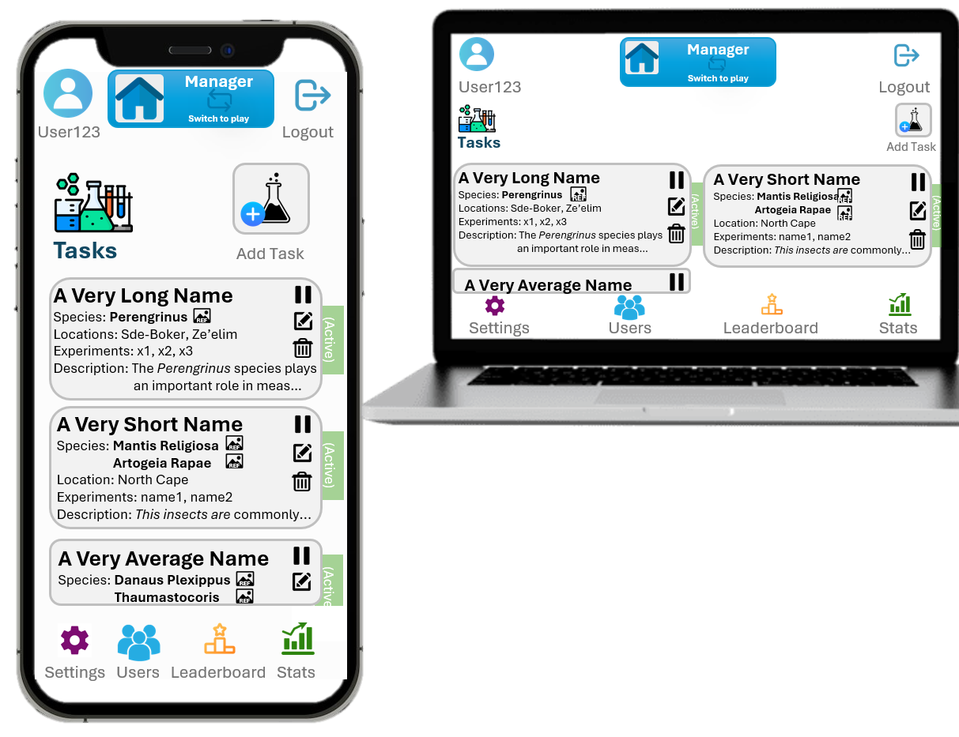
6.2.3 Add Task Page
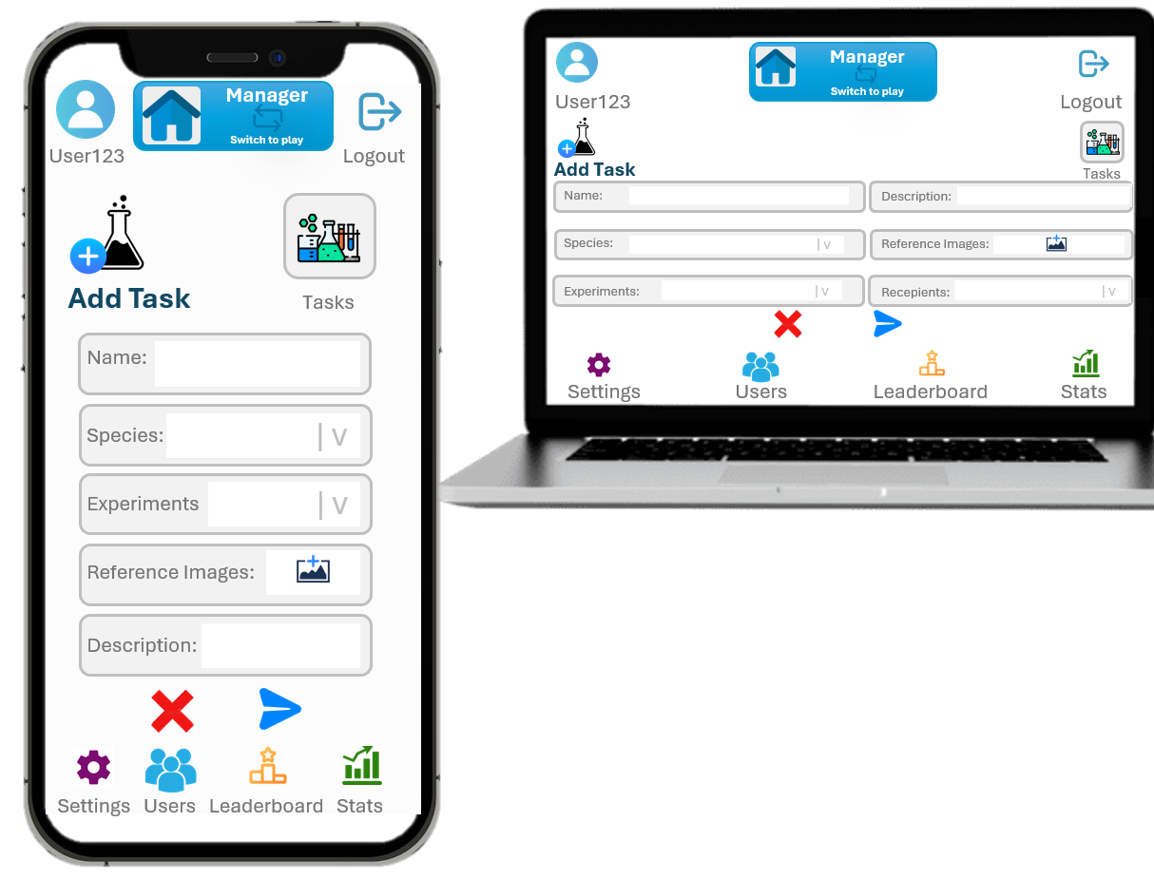
6.2.4 Taxonomy Info Page
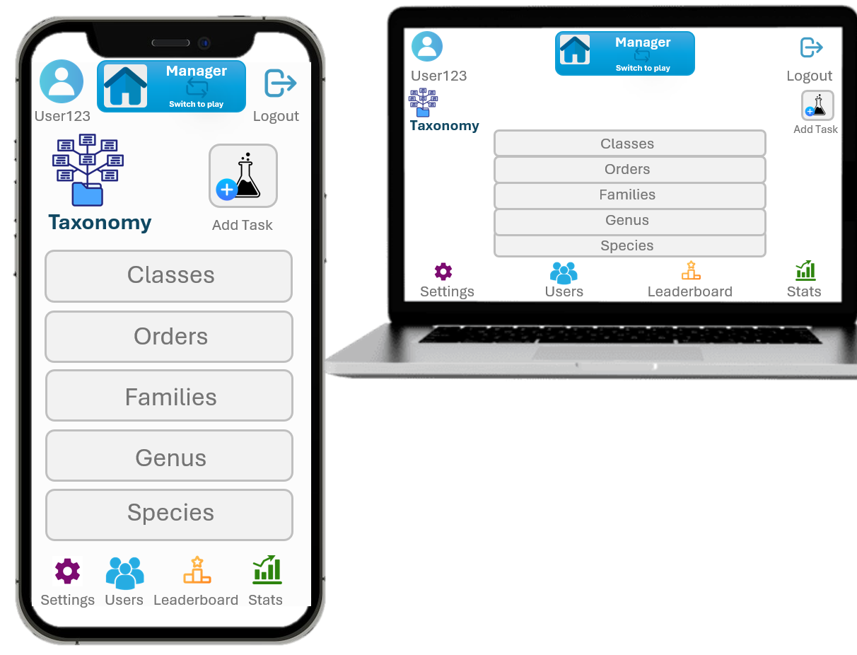

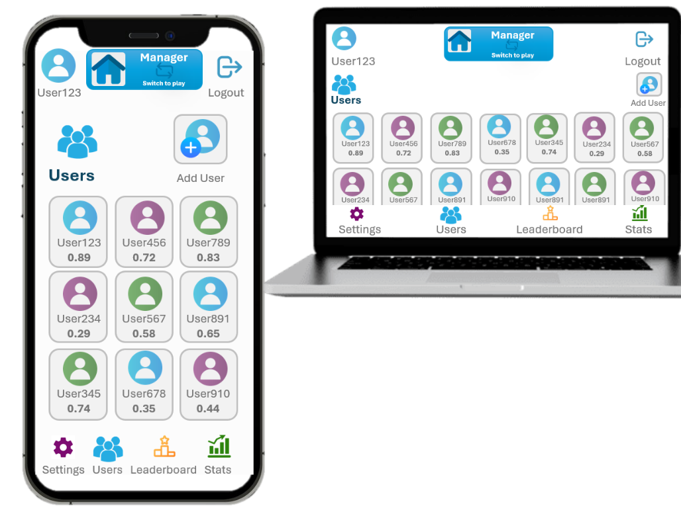
6.2.5 Users Management Page
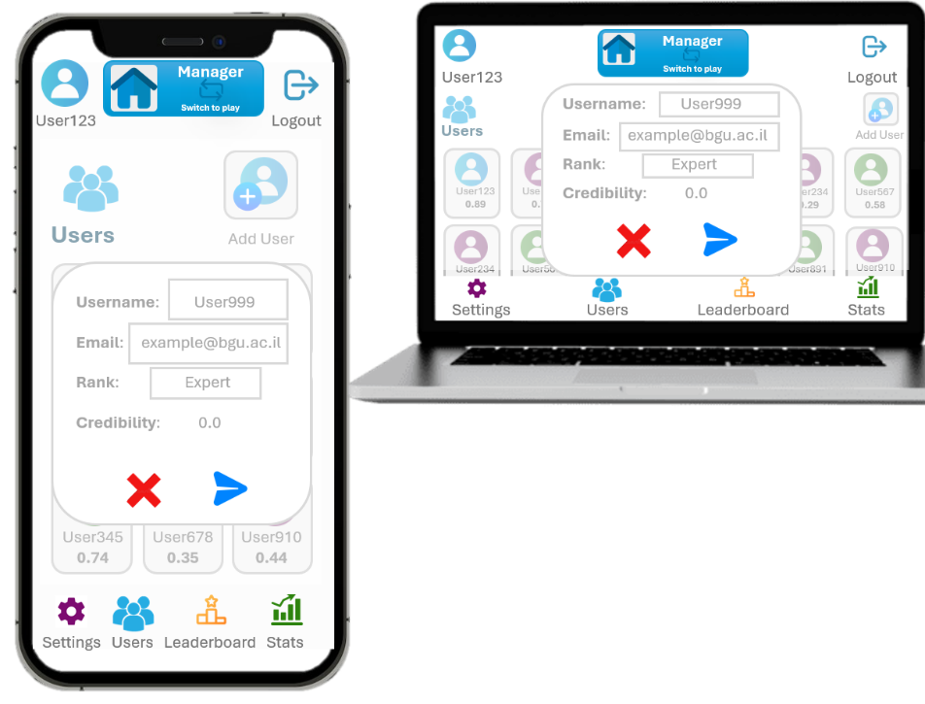

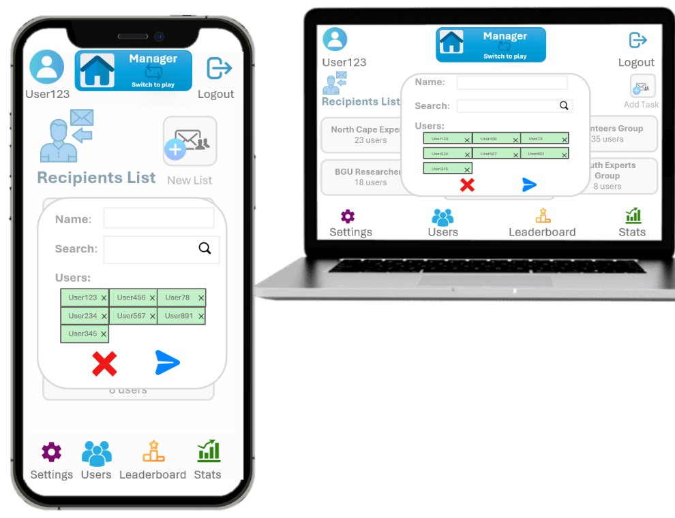
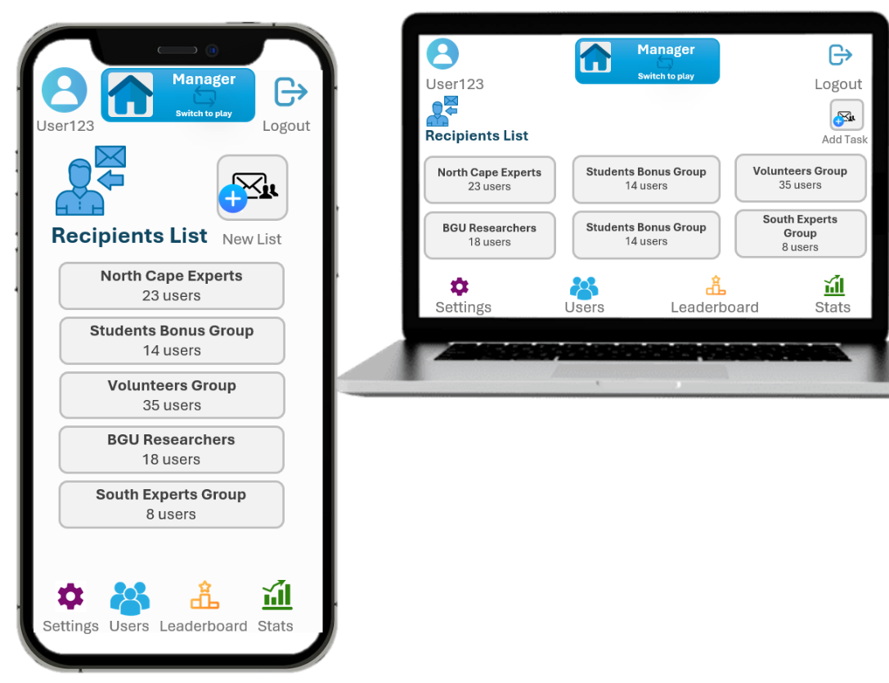
6.2.6 Recipients Management Page

6.2.7 Gold Images Management Page
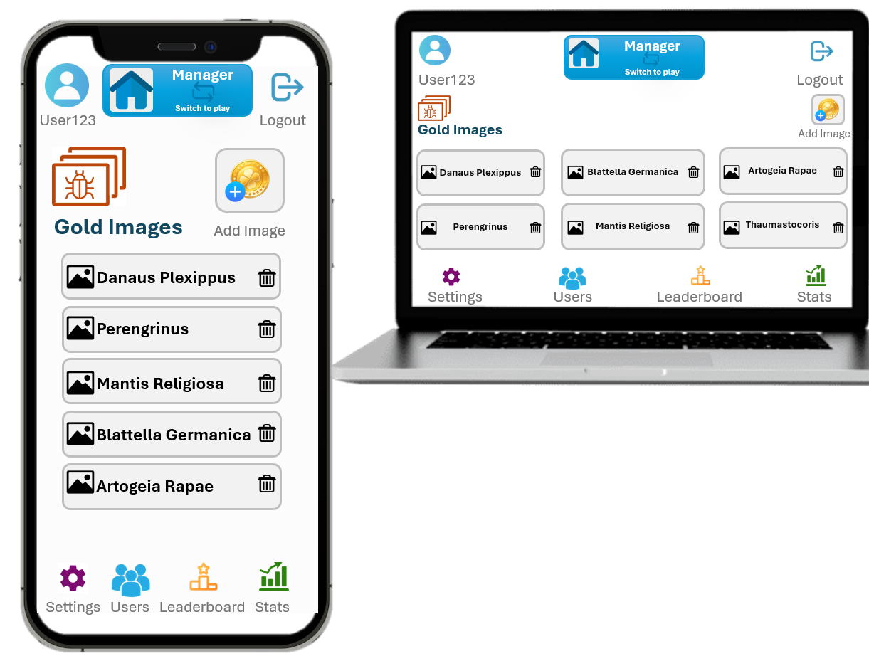
6.2.8 Add Gold Image Page
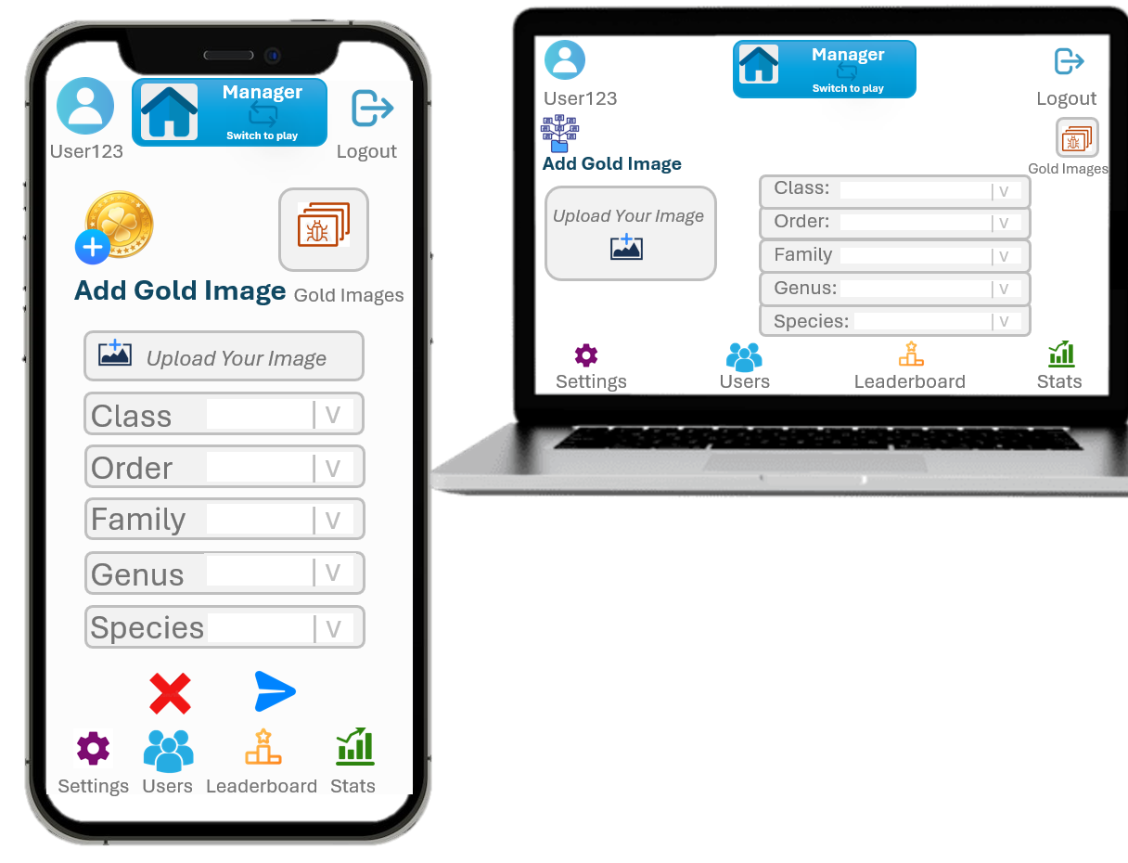

7. Testing
TODO !

8. Appendices
This appendix includes supplementary information that supports the understanding and validation of the requirements in this document. It provides technical details, background information, domain definitions, and references that may assist stakeholders, developers, and reviewers throughout the project lifecycle.

Appendix A — I/O Formats and Data Structures
This section describes the expected formats for data exchanged between SwipeLab and external systems (e.g., STARdbi API), as well as internal data structures.

A.1 Image Input Format (from STARdbi)
Data Source: STARdbi trap-scan database
Each classification task uses sub-images extracted from larger trap scans.
Typical API Response Structure (example):
{
"image_id": "stardbi_314159",
"trap_id": "T48",
"site": "negev_03",
"timestamp": "2023-05-14T21:33:00Z",
"image_url": "https://.../image_314159.jpg",
"metadata": {
"trap_scan_id": "scan_102",
"x": 341,
"y": 928,
"width": 64,
"height": 64
}
}

Notes:
- Images are served as JPEG/PNG.
- Some metadata fields may change depending on the final API design with the client.
- The prototype will initially use a simplified mocked structure.

A.2 User Classification Output Format
When a user submits a swipe classification:
{
"user_id": "user_123",
"image_id": "stardbi_314159",
"task_type": "wasp_binary",
"label": "positive",
"timestamp": 1711380010,
"client_device": "android",
"swipe_duration_ms": 892
}

A.3 Aggregated Label Output Format (for AI training)
Produced after consensus:
{
"image_id": "stardbi_314159",
"task_type": "wasp_binary",
"consensus_label": "positive",
"confidence": 0.86,
"votes_positive": 18,
"votes_negative": 3,
"num_users": 21
}

Appendix B — Background Information
This section includes context about the domain of the project and the underlying scientific need.

B.1 The STARdbi Initiative
SwipeLab is part of the larger STARdbi project, a database and research infrastructure for insect-trap imagery collected from 52 ecological sites.
Key Statistics:
- 1740 trap scans
- 350,000+ insect images
- Used by researchers in:
  - Ecology
  - Agriculture
  - Public health
- Purpose: Identify insect populations, species distribution, and ecological trends.

B.2 The Scientific Challenge
Research requires labeled images, but:
- Expert labeling is slow
- It is very expensive
- It is a major bottleneck preventing further analysis
- AI-based detection/classification models require large labeled datasets
SwipeLab converts a complex task into a binary, simple, gamified micro-task that non-experts can perform.

B.3 Similar Projects / Market Survey
The SwipeLab platform relates to existing “citizen science” projects:
- Zooniverse – large-scale crowdsourced scientific tasks
- Foldit – gamified scientific contribution
- iNaturalist – crowd-supported species classification
However, SwipeLab is unique in:
- Its binary swipe interaction (Tinder-style)
- Its focus on micro-classifications
- Its scientific integration with STARdbi
- Its focus on training AI classifiers directly

Appendix C — Survey & User Research
If user studies or interviews are conducted later, they can be documented here.
For now, planned forms of user study include:
- Short usability test with 5–10 non-expert users
- Feedback on clarity of binary task
- Assessment of swipe UX and image visibility
- Engagement-motivation survey (points, streaks, badges)
- Prototype performance testing on multiple devices

Appendix D — Glossary
This glossary defines domain-specific terms used throughout the document.

Binary Classification
A task where an item is categorized into one of two categories (e.g., “Wasp / Not Wasp”).
Consensus Labeling
Aggregating multiple user labels to determine a final classification with higher confidence.
Citizen Science
A scientific approach in which non-experts contribute data or analysis to help researchers.
Entomology
The scientific study of insects.
Gamification
The use of game-like mechanics (points, badges, leaderboards) to increase user engagement.
Insect Trap Scan
A large, high-resolution image produced by scanning an insect trap containing many captured insects.
STARdbi
A BGU research project providing a structured database of insect trap images for ecological, agricultural, and health-related studies.
Swipe Interaction
A gesture commonly used in mobile apps (left/right swiping) to classify or navigate.
Trap Site
A physical location where insect traps are placed to collect ecological data.
Training Dataset
A collection of labeled images used to train machine learning models.
Throughput
The number of images that can be loaded and classified per unit of time.
PoC (Proof of Concept)
A small experiment or prototype aimed at validating feasibility or identifying risks.

Appendix E — Potential Extensions (Future Work)
Future enhancements that may improve SwipeLab or extend its capabilities:
- Multi-class classification (instead of binary)
- Image segmentation to isolate insects automatically
- User reputation score influencing label weight
- Adaptive task difficulty
- Integration with trained ML models (human-AI collaboration)
- Global competitions and public achievements
- Expert dashboards for reviewing low-confidence labels
- Offline mode with delayed sync

Appendix F — References
- STARdbi official site: https://stardbi.cs.bgu.ac.il/home/welcome
- Industry best practices on citizen science platforms
- Tinder-style UX pattern references

